**Activity Diagrams with Swim-lanes for**

**DOST STARBOOKS: Whiz Challenge**

Project Documentation Submitted to the Faculty of the

School of Computing and Information Technologies

Asia Pacific College

In Partial Fulfillment of the Requirements for

Systems Analysis and Detailed Design

MSYADD1

Submitted by:

**Dumbrique, Kelly (Team Leader)**

**Gercan, Arcielle Marie (Member)**

**Quianzon, Shandrae Lois (Member)**

**Salipande, Janice Maxene (Member)**

G06 NEXUS – SF 231

Submitted to:

**Mr. Jose Eugenio L. Quesada**

Course Instructor

August 2025

1st Term

A.Y. 2025 – 2026

**1 - MANAGE PLAYER ACCOUNT**

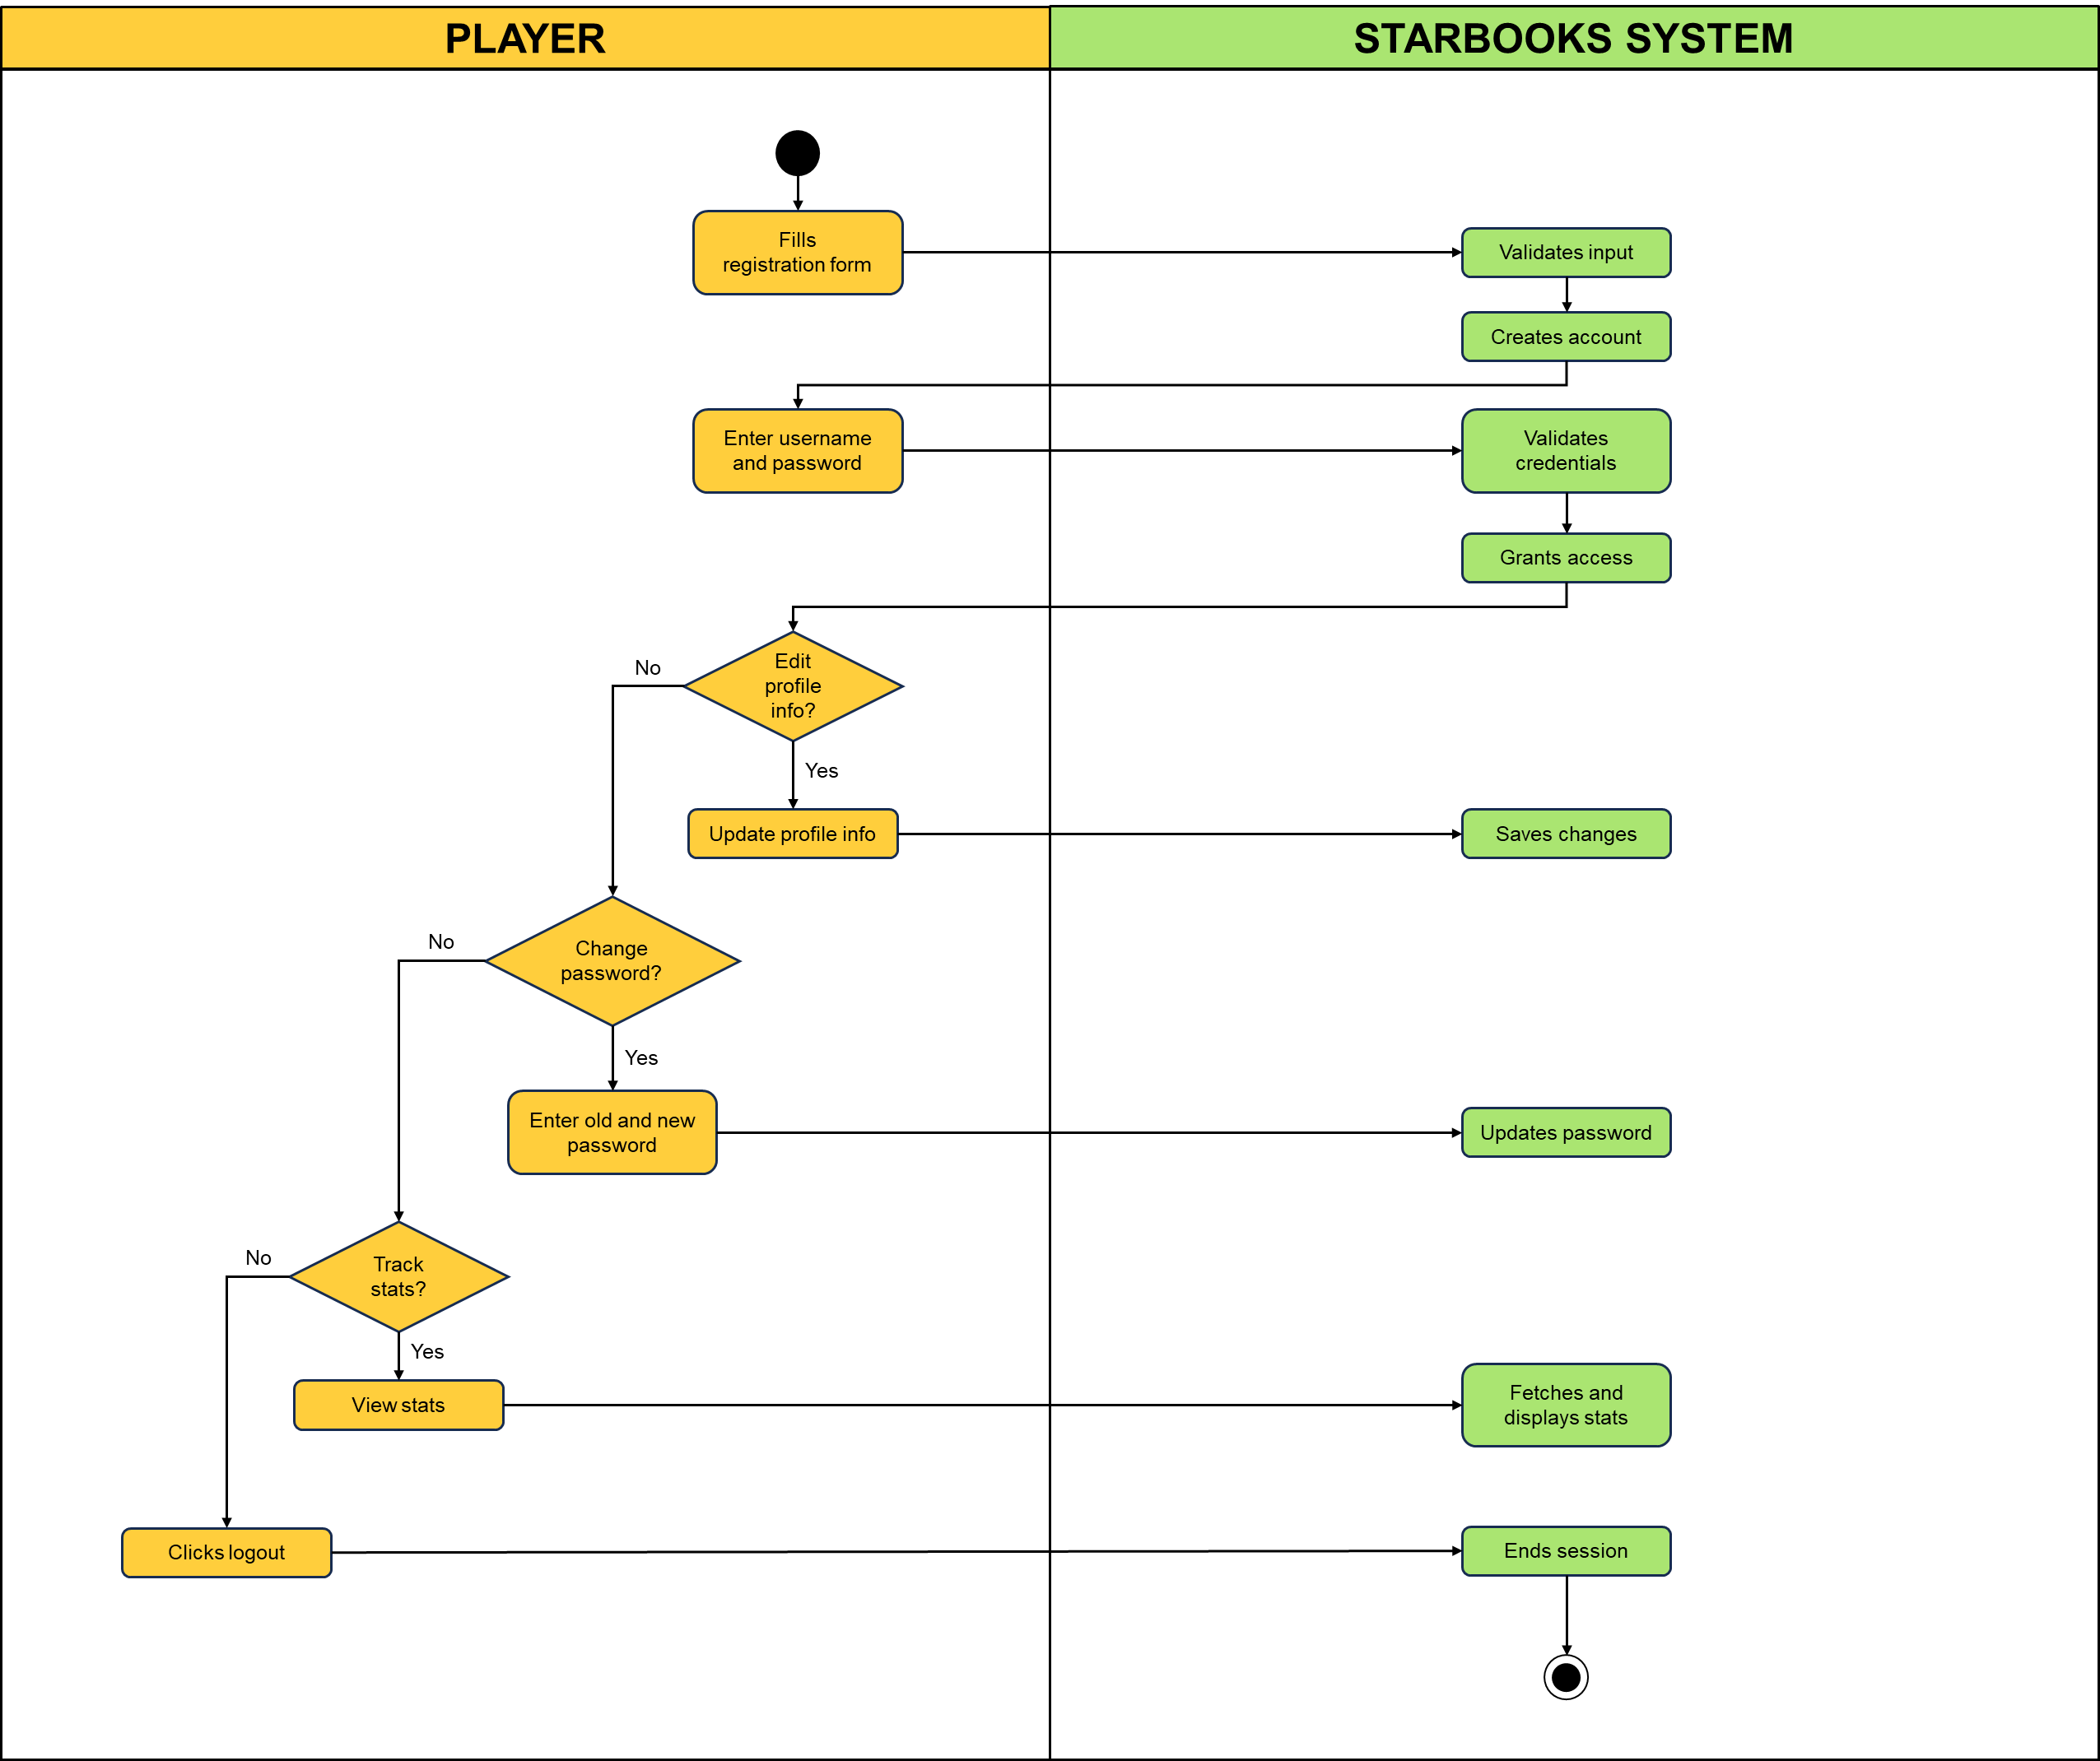

**2 - PLAY GAME**

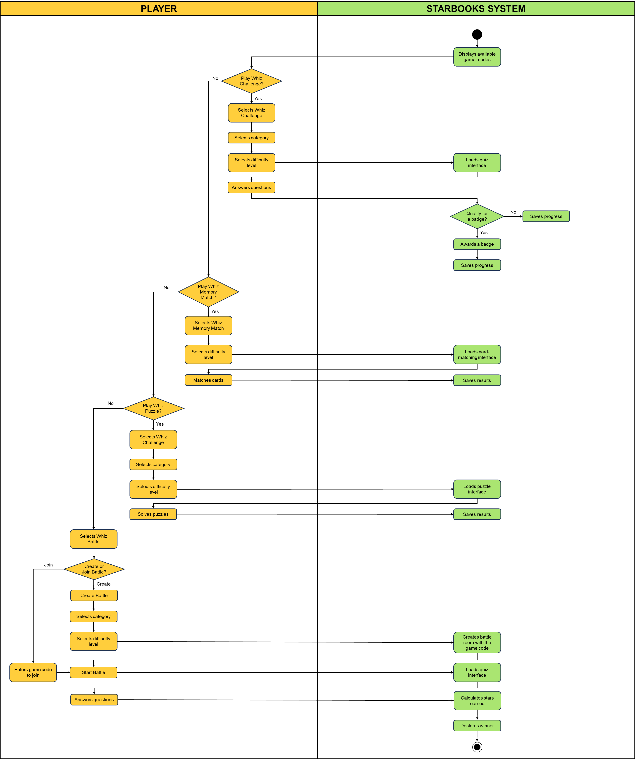

**3 - REWARD REDEMPTION**

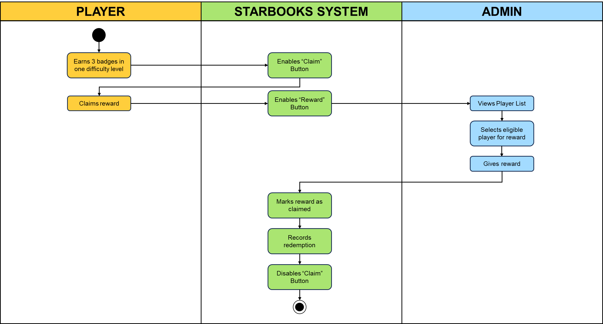

**4 - MANAGE ADMIN ACCOUNT**

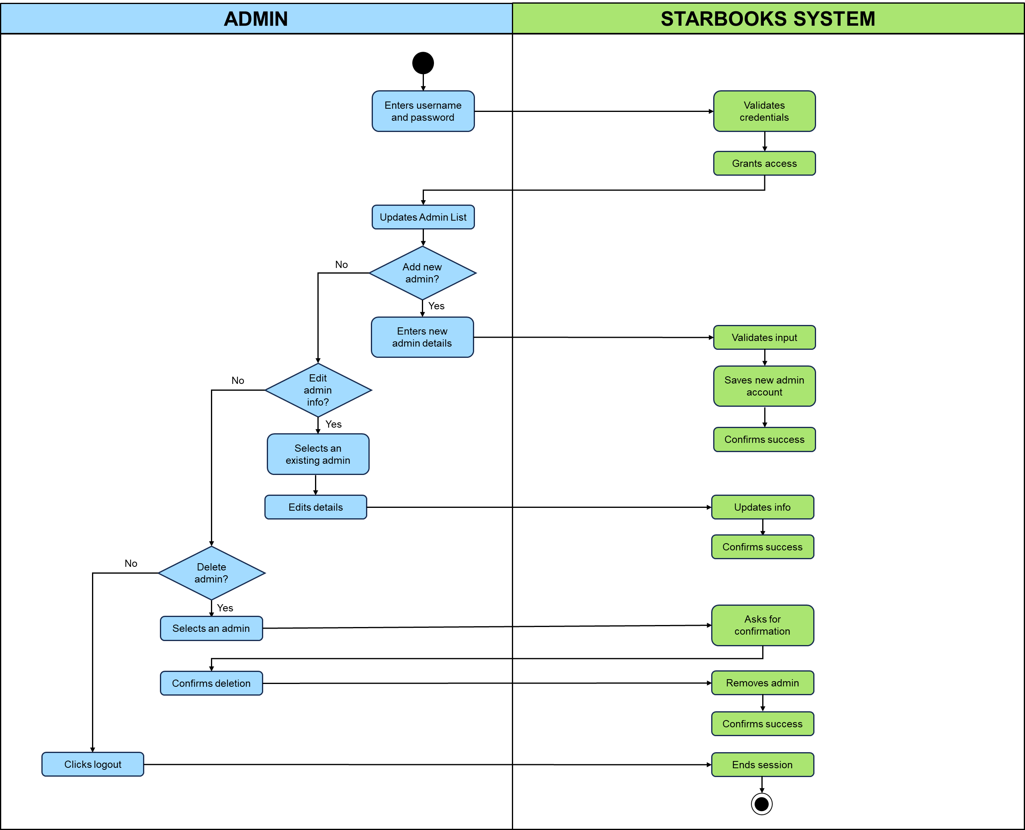

**5 - MANAGE QUIZ SETTINGS**

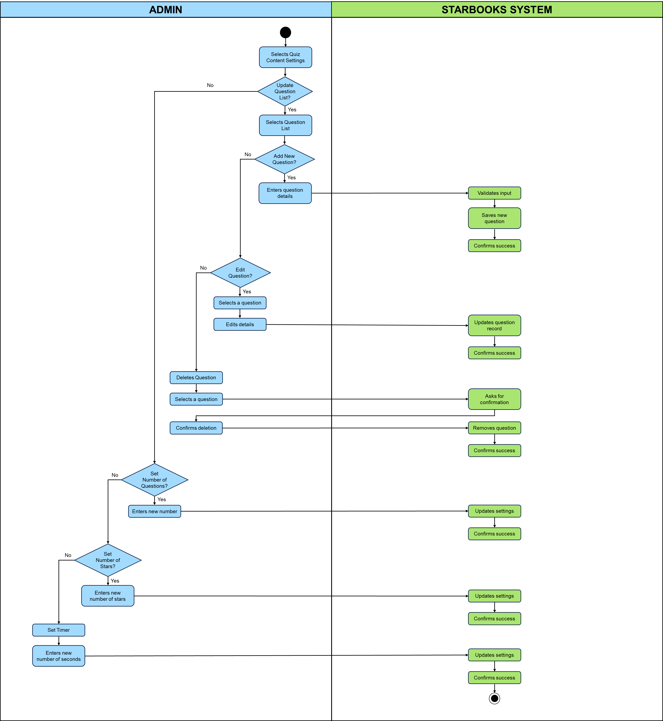

**6 - MANAGE PLAYER LIST**

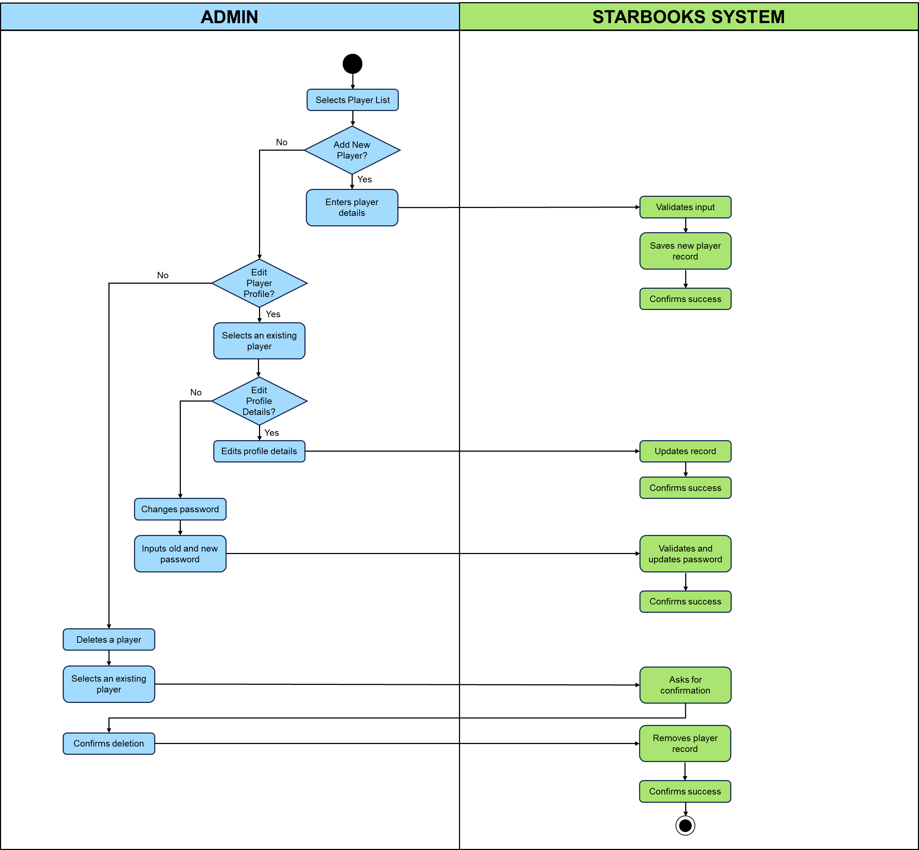

**7 - VIEW ANALYTICS DASHBOARD**

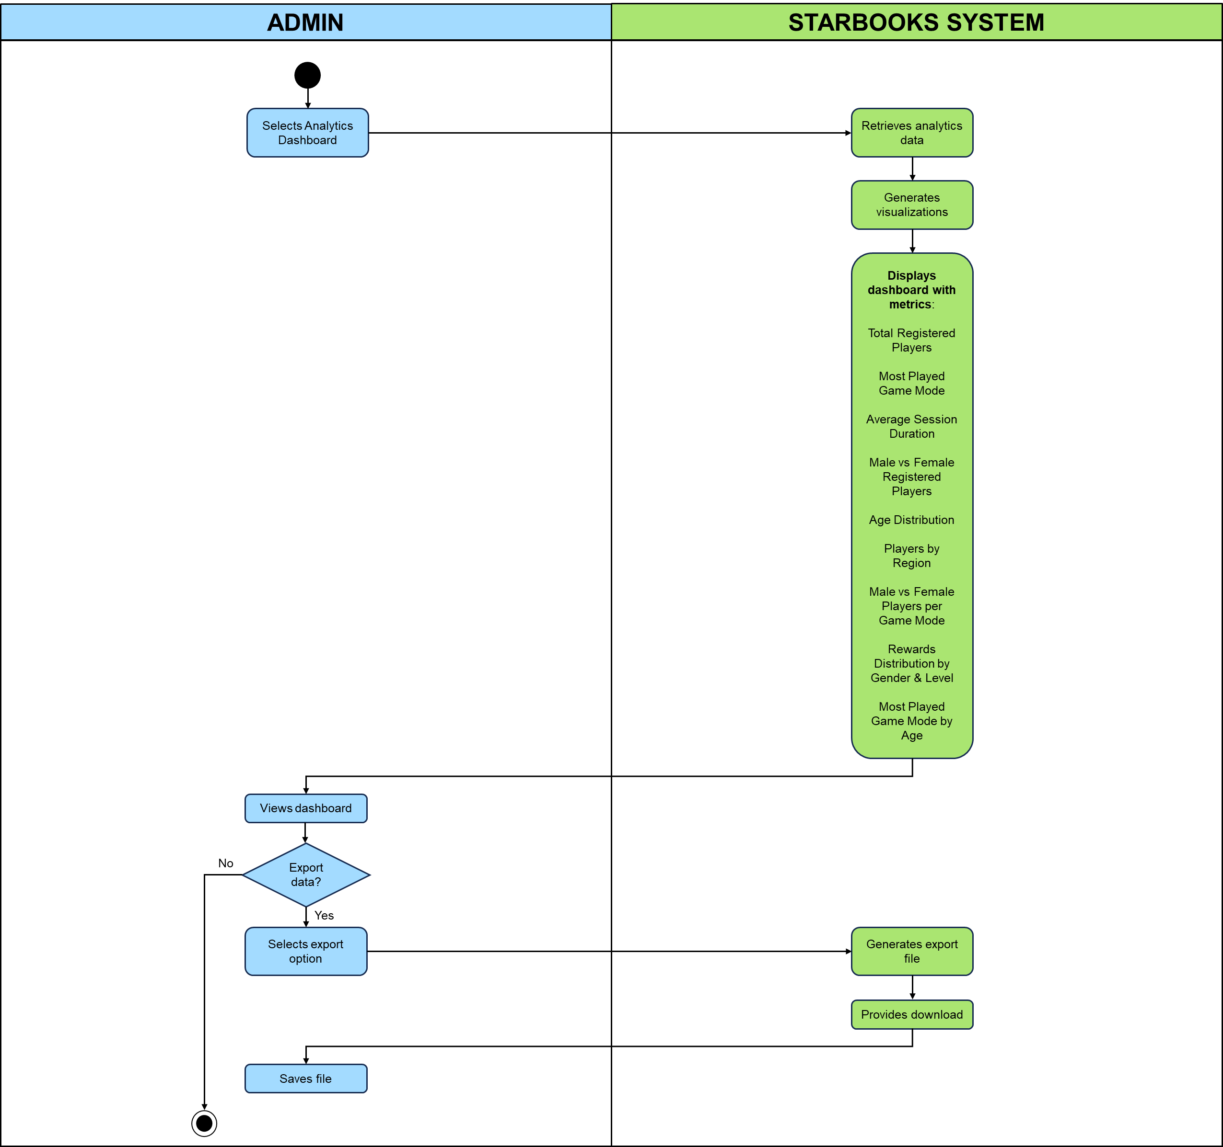

**8 - VIEW LEADERBOARD**

